BORRADOR PARA EVALUADORES EXTERNOS NACIONALES E INTERNACIONALES

Señor (a)____________

Estimado (a) señor (a):

Reciba un cordial saludo. Le escribimos desde _________________________ de la Universidad de Costa Rica (http://www.ucr.ac.cr/), le solicitamos su colaboración como par evaluador de la propuesta titulada _______________________________________________, cuyo resumen es el siguiente:

________________________________________________________

La evaluación consistiría únicamente en responder los siguientes 6 ítems con sus observaciones:
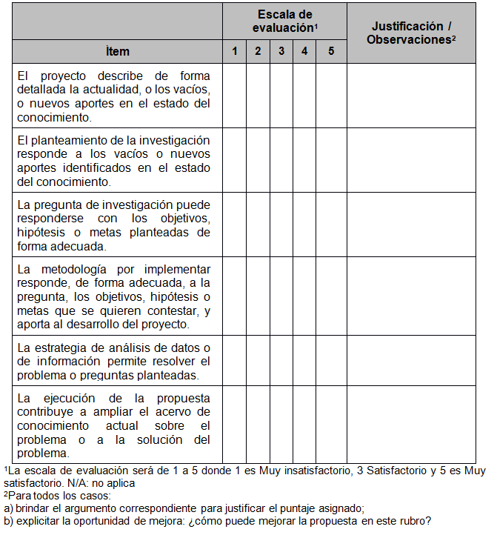

Le rogamos responder lo antes posible si podría asumir esta evaluación para hacerle llegar la propuesta completa.

Se le otorgará un plazo máximo de 10 días naturales para la respectiva evaluación a partir de la fecha en la que reciba la documentación de la propuesta.

Este compromiso conlleva aspectos de confidencialidad, por lo que le solicitamos abstenerse de reproducir los documentos que se entregan, devolverlos sin divulgar el contenido o cualquier material adjunto y usar esta información sólo para los propósitos de la evaluación. Por parte de _______________________, se asume el compromiso de mantener su nombre reservado.

Cualquier duda adicional puede contactarnos al ____________________ o al correo ________________________.

Agradecemos de antemano el apoyo a esta importante labor.

De usted con toda consideración,

_____________________________

DRAFT FOR NATIONAL AND INTERNATIONAL EXTERNAL EVALUATORS

Mr. / Mrs. / Ms.
_____________________

Dear Sir / Madam:

We write to you from _________________________ of the University of Costa Rica (http://www.ucr.ac.cr/), to request your collaboration as a peer evaluator for the proposal entitled _______________________________________________, whose summary is as follows:

________________________________________________________

The evaluation would consist solely of answering the following 6 items with their observations:

 | Evaluation Scale¹ |  |  |  |  | Justification /  Observations²
Item | 1 | 2 | 3 | 4 | 5
The project describes in detail the current situation, or gaps, or new contributions in the state of knowledge.
The research approach responds to gaps or new contributions identified in the state of knowledge.
The research question can be adequately answered through the objectives, hypotheses or established goals.
The methodology to be implemented adequately responds to the question, objectives, hypotheses or goals to be met and contributes to the development of the project.
The data / information analysis strategy allows solving the problem or questions posed.
The execution of the proposal contributes to increase the current knowledge on the issue or the solution of the problem.

¹The evaluation scale will be from 1 to 5 where 1 is Very unsatisfactory, 3 Satisfactory, and 5 Very satisfactory.
N / A does not apply
²For all cases:
a) Provide the corresponding argument to justify the assigned score;
b) Explain the opportunity for improvement: how can the proposal improve in this area?

If you could take on this evaluation, we ask you to respond as soon as possible, to send you the complete proposal.

You will be granted a maximum deadline of 10 calendar days for the respective evaluation from the date of receipt of the proposal documentation.

This commitment involves aspects of confidentiality, so we ask you to refrain from reproducing the delivered documents, return them without disclosing the content or any attached material, and use this information only for the purposes of the evaluation. _____________________ is committed to keeping your name reserved.

Should you have any additional questions, feel free to contact us at_________________ or the email___________________________________.

We thank you in advance for supporting this important work.

Very truly yours

_____________________________

