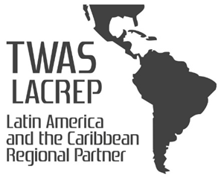

TWAS Young Scientist Prize 2019

Nomination/Application Form

Kindly read the information overleaf prior to completing the form.
- A candidate can be proposed by a TWAS Fellow, an Associate Fellow, also individual candidates may submit their own application.
- The candidates must be 39 years of age or less by January 1st, 2019

- Nominations must be sent by email (Subject: Young Scientist Prize) and should include:
  - Curriculum Vitae of the candidate.
  - The attached nomination form completed in all its parts, in English.
- The deadline for receipt of forms is August 10st 2019.
- Complete forms and enquiries should be directed to: twas-lacrep@abc.org.br
- Nominations must be submitted in the following format: aff_SURNAME_initial, eg aff_SILVA_m.doc

TWAS-LACREP Young Scientist Prize
2019

*Please (1) save the completed form under the candidate's name (in the format aff_SURNAME_Initial.doc e.g. aff_SILVA_m.doc) and send it to the TWAS LACREP Secretariat by e-mail (twas-lacrep@abc.org.br)

TWAS Member proposing the candidate ( this space is to be filled up only by TWAS Members)
Full Name:  Country: | Date:
Individual Application ( this space is to be filled up only for self-application)
Full Name:  Country: | Date:

Membership Details
The candidate should be considered by the TWAS LACREP Young Scientist Prize Committee for:

SOCIAL SCIENCES

Candidate's Details
Surname |  | Name
Current nationality: |  | Previous nationality:
Date of birth: | Town and country of birth:
Scientific field:
Position / Title:
Contact address (institution):

Phone: | Fax: |  | E-mail:

Candidate's Details (continued)
Exposition of the reasons that justify the nomination:

List of the candidate's 3 major international publications :

Names, addresses and EMAIL contacts of at least three referees.
Complete List of Publications:

