**Markus S. Schulz - Bio**

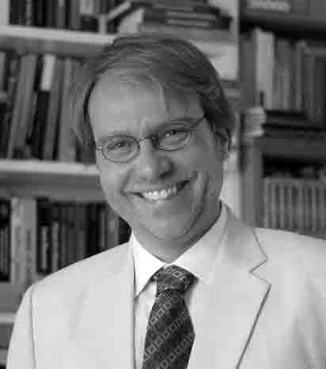**Markus S. Schulz** is Vice-President of the International Sociological Association (ISA) for the term 2014-18 and he will be President of the 2016 ISA Forum of Sociology in Vienna, for which he proposed the theme “The Futures We Want: Global Sociology and the Struggles for a Better World”. Professor Schulz completed two successful terms as President of the ISA Research Committee on Futures Research (2006-2014) and served as a Program Committee member for the previous ISA World Congress in Yokohama.

Schulz’s research focuses on democracy, globalization, media, movements, and the social imagination. He is currently at the New School for Social Research where he investigates the intellectual history of future concepts.

Schulz won for his work international recognition, including the ISA’s Bielefeld Prize for the Internationalization of Sociology, the Eastern Sociological Society’s Candace Rogers Award, and the American Sociological Association’s Elise Boulding Award.

Schulz is a passionate teacher who has taught a wide spectrum of courses from first semester general introductions to specialized doctoral seminars at the University of Illinois at Urbana-Champaign, New York University, Virginia Tech, City University of New York, and Bauhaus University of Weimar, Germany.

Schulz has given talks at universities and scholarly conferences in Argentina, Australia, Brazil, Canada, Costa Rica, Cuba, Germany, Greece, Israel, Italy, Japan, Lebanon, Mexico, Peru, Poland, Puerto Rico, South Africa, Spain, Sweden, Switzerland, USA.

Schulz earned his PhD at the New School for Social Research’s Graduate Faculty of Political and Social Science in New York City, following studies at the Freie and the Humboldt University of Berlin, Germany.

Schulz co-authored the six-volume book series on *Internet and Politics in Latin America: The Regulation and Usage of the New Information and Communication Technologies in the Context of Political and Economic Transformations* (Frankfurt: Vervuert, 2003; Vol. 1 bilingual in German and Spanish). He edited for the journal *Current Sociology* special issues on *Values and Culture: The Shaping of Future Society* (2011) and on *Future Moves: Studies in Culture, Science, and Technology* (2015).

Among his numerous journal articles in English are “Collective Action across Borders: Opportunity Structure, Network Capacity and Communicative Praxis in the Age of Advanced Globalization” (*Sociological Perspectives*, vol. 41:3) and “Debating Futures: Global Trends, Alternative Visions, and Public Discourse,” *International Sociology* (forthcoming).

Schulz is the founding curator of the online WebForum on The Futures We Want: <http://futureswewant.net>.

Among his articles in Spanish are:

* “Nuevos medios de comunicación y movilización transnacional: El caso del movimiento Zapatista,” *Perfiles Latinoamericanos*, Vol. 22, no. 44 (July-December) 2014, pp. 171-194.
* “La alianza de las grandes democracias del sur. Desafíos de desigualdad,” *Horizontes Sociológicos: Revista de la Asociación Argentina de Sociología*, Vol. 2, no. 3 (January-June) 2014, pp. 10-29.
* “Futuros del Sur: Ciencias sociales, descolonización de la imaginación y la lucha para igualdad y participación,” *Horizontes Sociológicos: Revista de la Asociación Argentina de Sociología*, Vol. 1, no. 1 (January-June), 2013;

related version republished in:

*Controversias y Concurrencias Latinoamericanas – Revista de la Asociación Latinoamericana de Sociología (ALAS)*, 2013, Vol. 5, no. 8.

* “Democracia y Cambio de los Medios en América Latina,” *Perfiles Latinoamericanos*, Vol. 10, No. 18; (June) 2001, pp. 9-28.

Web: <http://markus-s-schulz.net>