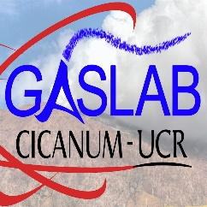
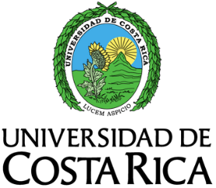
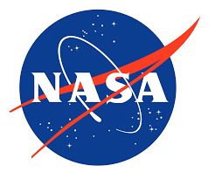

9th Ticosonde Interdisciplinary Science Workshop
10am-3pm Wednesday, 23 March 2022
Universidad de Costa Rica Sala Multiusos Plaza de la Autonomía

1000-1005: Welcome
Elian Conejo/Ryan Stauffer

1005-1010: Introductory Remarks
Maria Laura Arias Echandi, UCR Research Vice-Rector

1010-1020: UCR CICANUM Activities
Elian Conejo, UCR CICANUM Director

1020-1035: “NASA Earth Science and The Role of Ground-based Observations”
Henry Selkirk, NASA HQ

1035-1050: “Preliminary results from the OTREC 2019 Campaign using radiosonde data from Limón (Caribbean) and Santa Cruz (Pacific)”
Marcial Garbanzo, UCR School of Physics

1050-1100: Coffee Break

1100-1115: “Use of radiosonde data to validate regional climate models and infer moisture vertical profiles”
Ana María Durán Quesada, UCR School of Physics

1115-1130: “Volcanic air dispersion modeling to estimate SO₂ concentrations in Costa Rica”
Jose Sibaja Brenes, UNA

1130-1145: “AERONET in Costa Rica and Beyond”
David Giles, NASA/GSFC

1145-1200: Ticosonde and CICANUM GasLab Operations
Alfredo Alan and Ernesto Corrales, UCR CICANUM GasLab

1200-1215: United States Embassy and Regional Environmental Hub Activities
Geoffrey Thomas, US Embassy San José

1215-1230: “Upper tropospheric/lower stratospheric water vapor observations at San Jose, Costa Rica”
Holger Vömel, NCAR

1230-1330: Lunch Break

1330-1345: Hunga Tonga Volcanic Eruption effects on Water Vapor
Holger Vömel, NCAR

1345-1400: “Costa Rica and the SHADOZ Tropical Ozonesonde Network”
Ryan Stauffer, NASA/GSFC

1400-1415: “Chemical modeling with Costa Rica measurements of water vapor and ozone: Implications for oxidation”
Julie Nicely, University of Maryland

1415-1430: Ticosonde Outreach Activities
Megan Damon, SSAI

1430-1500: Placeholder for any yet-to-be-confirmed presentations
To Be Determined

1500: Closing Remarks and Post-Workshop Coffee
Elian Conejo/Ryan Stauffer

