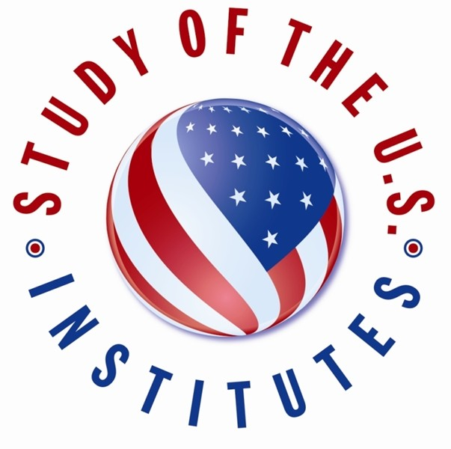

Study of the U.S. Institutes (SUSI) for Scholars and Secondary Educators Nomination Form

- Required

- FULL NAME:

Select the SUSI Institute: *

SUSI for Scholars (go to question 3)
SUSI for Secondary Educators (go to question 2)

Select the Theme of the SUSI Institute (Secondary Educators): *

Secondary Educators - Teachers Secondary Educators - Administrators

Select the Theme of the SUSI Institute (Scholars): *

U.S. Culture, Identity, and Society Journalism and Media
American Politics and Political Thought

U.S. Economics and Sustainable Development

U.S. Foreign Policy

Contemporary American Literature

SECTION A: CANDIDATE INFORMATION
Please provide information exactly as it appears in the candidate's passport.

Surname (Last Name): *
- Given Names *

Gender: *

Female Male
Non-binary Other

Date of Birth: *

- City of Birth: *
- Country of Birth: *

Primary Citizenship: *
- Country of Residence: *

Candidate Contact Information:

Street Address: *

City:

State/Province:

Postal Code:

Country:

- Phone Number: *
- Email Address: *

Medical, Physical, Dietary, or other Personal Considerations:
This will not affect a candidate's selection, but will enable the host institution to make any necessary accommodations. Please indicate if the candidate has a disability.

Please indicate if the candidate has a disability: *

None

Blind or Visual Impairments Deaf or Hearing Impairments Learning Disability
Physical Disability Psychiatric Disability Systemic Disability
Other

- Please describe any pre-existing medical conditions, including any prescription medication required, dietary restrictions, or personal considerations. *

Experience in the United States:

Has the applicant traveled to the United States before? *

Yes No

If yes, please list any previous travel to the United States for the purposes of tourism/vacation, conferences, educational study, or previous ECA related grants. Provide dates/duration, purpose of visit(s), and location. (Example: July 4-14, 2019 Tourism to Washington, D.C.; December 1-15 2018, Short Term Study Abroad to New York City, NY.)

- Has the applicant previously participated in or been accepted into a U.S. Department of State sponsored program? *
Yes No

If Yes, please provide the name of the program and the dates. *
- Family residing in the United States (if applicable):
Please include relation information, city, and state. (Example: Jane Doe, sister- Denver, CO)

SECTION B: CANDIDATE BACKGROUND

Education: *
Please list all earned degrees beginning with the most recent. Each entry should include the following information:
Degree Earned (Degrees should reflect the closest U.S. equivalent.) Year Awarded
Specialization Institution
(Example: Master's; 2019; International Relations; American University)

Additional Academic/Professional Training/ Workshops: *

- Current Role/Job Title: *

Institution/Organization Name (Faculty/School/University): *

- Institution/Organization Country: *

Work History: *
Please limit work experience to the FIVE most recent job positions. Please provide the following information for each entry:
Institution
Dates of Employment (Month/Year-Month/Year) Title/Position (please specify if part-time)

(Ex. American University; 01/2019-01/2020; Professor of International Relations)

Professional Responsibilities: *
Nominees should discuss professional responsibilities in greater detail, including research interests, administrative responsibilities (example: curriculum design), and/or other
pertinent information not included in the section above.

Current Courses Taught: *
If the candidate is not currently teaching courses, please indicate NOT APPLICABLE. Please include the following information for each course:
Course Title
Indicate Level of Students (Secondary School Students/Undergraduate Students/Graduate Students)
Classroom Hours per Semester Number of Students
Percent of U.S. Studies Content

Current Student Advising:
Advising is not the same as teaching. If the candidate advises students please input the number of students, their level, and hours the candidate spends providing assistance in helping students clarifying personal and career goals, and evaluating progress towards those goals. This section can also include those that supervise Ph.D. and graduate
students.
Please include the following information:
Number of Students Advised Studying U.S. Related Topics
Indicate Level of Students (Secondary School Students/Undergraduate Students/Graduate Students)
Hours of Advising Per Student Per Year

Publications Related to the Institute Theme:
Please list all foreign titles in English, including whether the publication was a book, chapter, journal article, newspaper article, etc. Please only list publications within the last five years.

Active Memberships in Professional Associations:
Please limit to three most relevant. Provide the position and organization. (Example: President, Washington Educational Professionals Association.)

Other Leadership Positions Beyond Professional Duties:
Please provide the activity, position/title, year started, year completed, and the description of duties.

Potential Outcomes: *
Please select any likely potential professional outcomes of this program:

Create New Course

Create New Degree Program School Curriculum Redesign National Curriculum Redesign New Research Project
New Publication

Professional Promotion

Government or Ministry Policy New Professional Organization New Institutional Linkages
Raise Institutional Profile

Candidate Personal Statement: *
As part of the SUSI application process, candidates should submit a personal statement about their background and goals. In up to 500 words, the candidate should address the following questions and any other pertinent information:
Why are you interested in participating in the Institute? What do you hope to gain from the Institute?
What will you contribute to the Institute?
How will you leverage the experience to achieve "other potential outcomes" checked in the above section?
How will you amplify the impact of the program beyond your research and knowledge?

