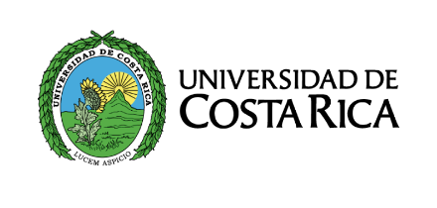
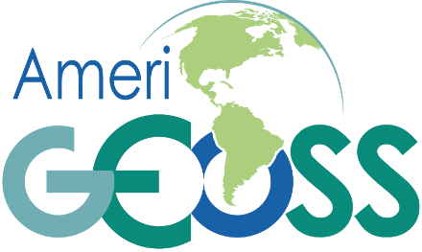

AmeriGEOSS Week 2017
July 31st – August 4th, 2017
Draft Agenda
Day 1 – July 31st, 2017
Morning: Opening Plenary
8:30am | Registration
9:00am | Opening Plenary  - Remarks by  - Costa Rica Principal (Dr. Juan Carlos Fallas)3  - University official (TBD)4  - Costa Rica government representatives (TBD)2  - GEO Secretariat (Douglas Cripe)1  - Other participating organizations in the region (e.g. GEOSur, CAF, etc.)?
11:00am | Demonstration of the AmeriGEOSS Community Platform to Caucus and Regional Working Group members  Training sessions and Introductions for GEOGLAM, GEONETCast, and SAR
11:45am | Break/Lunch

Day 1 – July 31st, 2017
Afternoon: Joint Americas Caucus, AmeriGEOSS CWG, and Priority Area WGsMeeting / Training Sessions begin
1:00pm | Joint Americas Caucus and AmeriGEOSS Meeting
- Presentation on activities from each of the countries
- Presentations on each of the priority areas (thematic and foundational activities)
- Presentation on progress from CWG
- Short descriptions/demonstrations from each of the training sessions (?)
- Demonstration of the community platform and show use case examples for the different priority areas.

Training sessions for GEOGLAM, GEONETCast, and SAR
2:30pm | Break
2:50pm | Reconvene
3:00pm | Community Platform Breakout Groups for exploration of Platform and development of Use Cases
5:00pm | Adjourn

Day 2 – August 1st, 2017
All Day: Joint Americas Caucus, AmeriGEOSS CWG, and Priority Area WGs Meeting / Concurrent Training Sessions
8:45am | Convene
9:00am | Discussion on current priorities from each of the countries’ principals  - What do you most want to promote?  - How can you champion one of the activities?  - What topic areas are most important to your country?  Training sessions for GEOGLAM, GEONETCast, and SAR
10:30am | Break
10:45am | Reconvene
10:50am | - Discussion on communicating the benefit of GEO and AmeriGEOSS  - Objective: Develop a strategy for each principal to be able to communicate the benefit of GEO and AmeriGEOSS in their countries. Perhaps a template presentation?  Training sessions for GEOGLAM, GEONETCast, and SAR
12:00pm | Lunch
1:00pm | Reconvene
1:00pm | Continued discussion on Communicating the benefit of GEO and AmeriGEOSS  Training sessions for GEOGLAM, GEONETCast, and SAR
2:00pm | Break
2:15pm | Reconvene
2:20pm | Caucus Administrative Business  - Vice Chair selection of the AmeriGEOSS Coordination Working Group  - GEO Executive Committee membership/representation  - Selection of AmeriGEOSS Week 2018 location and date  - Other business?  Training sessions for GEOGLAM, GEONETCast, and SAR
5:00pm | Adjourn

Day 3 – August 2nd, 2017
All Day: National Holiday (perhaps we could schedule a self funded tour(s) for the group? Visit a museum or day trip to volcano, coffee plantation, biodiversity/rainforest tour, etc.)
Day 4 – August 3rd, 2017
All Day: Concurrent Training Sessions
Day 5 – August 4th, 2017

All Day: Concurrent Training Sessions

